Mutagenic effects of sodium azide on pineapple micropropagant growth and biochemical profile within temporary immersion bioreactors.
Julia Martínez¹, Daviel Gómez^{1,2}, Lázaro Hernández¹, Julia Martínez¹, Janet Quiñones¹, Byron E. Zevallos³, Sershen⁴, Lourdes Yabor¹, José Carlos Lorenzo¹
¹ Laboratory for Plant Breeding, Bioplant Center, University of Ciego de Avila, Ciego de Ávila, 69450, Cuba, E-mail: jclorenzo@bioplantas.cu
² Laboratorio de CarboCat, Departamento de Ingeniería Química, Facultad de Ingeniería, Universidad de Concepción, Región del Bio Bio, Chile.
³ Escuela Superior Politécnica Agropecuaria de Manabí Manuel Félix López (ESPAMMFL), Campus Politécnico El Limón, Carrera de Ingeniería Agrícola, Calceta, Manabí, Ecuador.
⁴ School of Life Sciences, University of Kwazulu-Natal, Durban, 4001, South Africa.

Summary
Sodium azide (NaN₃) is widely used to induce mutagenesis within in vitro plant systems. However, since this mutagenesis is undirected, its unintended effects demand characterization. This study investigated the mutagenic effects of sodium azide (0 - 0.45 mM) on selected growth (shoot multiplication rate and shoot cluster fresh weight) and biochemical (aldehydes, chlorophylls, carotenoids and phenolics) parameters in pineapple micropropagants within temporary immersion bioreactors (TIBs). The content of soluble phenolics in the culture medium was also evaluated. Irrespective of the concentration NaN₃ decreased shoot multiplication rate (by 87% relative to the control at 0.45 mM) and fresh weight (by 66% relative to the control at 0.45 mM). Levels of chlorophyll a and b, and soluble phenolics in the culture medium were also negatively correlated with NaN₃ concentration. Interestingly, NaN₃ application increased shoot carotenoid and soluble phenolic levels but had no significant effect on a range of established plant stress biomarkers: cell wall-linked phenolic levels, malondialdehyde and other aldehydes. Given that 0.19 mM NaN₃ decreased shoot multiplication rate by 50% and resulted in propagants that displayed no morphologically abnormalities, increased levels of photoprotective pigments (relative to the control) and no significant increase in lipid peroxidation products, the mutagen can be used at this concentration to induce pineapple mutagenesis in TIB based studies aimed at producing agriculturally-useful mutants.
Keywords In vitro stress; in vitro mutagenesis; plant metabolites; Ananas comosus (L.) Merr.; plant breeding
Abbreviations Sodium azide (NaN₃); temporary immersion bioreactor (TIB).
Introduction
Plant breeders have generated new varieties using chemical mutagens for many decades (Dubey et al., 2017). Sodium azide (NaN₃) is widely regarded as a relatively safe to handle and very efficient chemical mutagen that is both inexpensive and non-carcinogenic (Salvi et al., 2014). This common laboratory chemical is used widely in organic synthesis, agricultural and medical research (most often as bactericide, pesticide and nitrogen gas generator) but it is most famous for its mutagenic effects in plants and animals (Mendiondo et al., 2016). This mutagenic capacity is based on NaN₃’s production of an organic metabolite, β-azidoalanine, which is valued for its ability to induce chromosomal aberrations at a rate much lower than other mutagens (Dubey et al., 2017).
The concentrations of NaN₃ that are used for the treatment of plant tissues vary widely across species: e.g. 3 – 10 mM (Castillo et al., 2001) or 0.5 – 4.0 mM in Hordeum vulgare (Szarejko et al., 2017); 1.0 – 3.0 mM in Pisum sativum (Divanli-Türkan et al., 2006); 0.04 - 1.1 mM in Phaseolus vulgaris (Chen et al., 2011); 15.5 – 77.6 mM in Trigonella foenum-graecum (Siddiquia et al., 2007); and 31.1 – 124.3 mM in Brassica napus (Hussain et al., 2017). However, we have not found any report on the use of NaN₃ during in vitro production of axillary buds. Despite the wide range of concentrations at which NaN₃ is used, the mutagen generally acts by creating point mutations in the genome, disturbing metabolic activity, growth and development, and inhibiting protein and DNA replication (Ragunathan and Panneerselvam, 2007). These effects, the severity of which are concentration dependent (Vainstein, 2002), change the balance between growth promoters and their antagonists (Gruszka et al., 2012). Nevertheless, a number of traits have been improved in a variety of species using NaN₃, including days to germination, flowering and silique maturation in Brassica napus (Hussain et al., 2017); related to quality, yield and disease resistance in wheat (Dubey et al., 2017); germination, seedling survival, root length and height, height at maturity, number of leaves, and fruit yield in tomato (Adamu and Aliyu, 2007); and groundnut yield (Mensah and Obadoni, 2007). The mutagen has also been applied to a variety of explant types: e.g. cultures of Pisum sativum seeds (Divanli-Türkan et al., 2006), tomato seeds (El Kaaby et al., 2015), Brassica napus cotyledons (He et al., 2011), and Hordeum vulgare anthers and microspores (Castillo et al., 2001). Although the TIB technique is known to increase multiplication rates in many crop species (Jiménez et al., 1999), the use of this culture technique for the NaN₃ application has not been reported to date.
The increased multiplication rates in TIBs might be caused by the combined advantages of using a solid and liquid culture medium. Micropropagation on solid culture medium allows plant air exchange but nutrient uptake is limited to the explant basal surface (Escalona et al., 1999). On the other hand, whilst micropropagation in liquid culture medium increases nutrient uptake, it often leads to hyperhydricity (Ziv, 1995). Hyperhydricity is characterized by various degrees of morphological and physiological disorders which can include a glassy, waterlogged-tissue appearance and disordered shoot growth (more specifically in the leaves). Unlike the classic liquid culture procedure (Alvard et al., 1993), in a TIB explants are covered with the culture medium only for a few minutes and immersion allows nutrient uptake through the entire explant surface. The plant air exchange is restored after removal of the culture medium. Irrespective of the in vitro culture method, explant type or species, the mutations underlying the changes induced by chemical mutagens like NaN₃ are undirected and as alluded to above can have negative effects on plant growth and performance. This necessitates the characterization of the unintended effects of NaN₃ exposure and identification of the optimum concentration for application within specific species.
Pineapple is the main commercial species of the Bromeliaceae globally (Martín et al., 2015). Fruit production in pineapple reached 25.4 million tons in 2013 (FAOSTAT, 2016) but to maintain and/ or improve the quality of pineapple production in many parts of the world, researchers are now developing new varieties (Yabor et al., 2016). Given that pineapple breeding through conventional techniques is extremely costly (Loison-Cabot and Lacoeuilhe, 1989), biotechnological approaches (e.g. induced mutagenesis) provide great potential for improving selected clones more affordably.
In vitro-induced mutagenesis has been employed to produce improved genetic variants in numerous crop species, including pineapple (Ibrahim et al., 2009). Research on the efficacy of chemical mutagens, specifically NaN₃, in inducing mutagenesis in pineapple is limited and hence, forms the focus of the present research. The study investigated the mutagenic effects of NaN₃, applied at a range of concentrations (0 - 0.45 mM), on selected growth (shoot multiplication rate and shoot cluster fresh weight) and biochemical (aldehydes, chlorophylls, carotenoids and phenolics) parameters in pineapple micropropagants TIBs. Soluble phenolic content in the culture medium was also assessed. The selection of TIBs for the study is based on the high multiplication rate of pineapple (1:66) using this technique, compared with conventional micropropagation containers (1:8) (Escalona et al., 1999).
Materials and methods
Plant material, in vitro methods and growth measurements
Feld-grown pineapple plants (cv. MD2) served as the source of explants for initiating in vitro cultured buds (Daquinta and Benegas, 1997). These axillary buds, excised after removal of the crown leaves, were decontaminated (with 1% (w:v) Ca(ClO)₂ for 10 min) followed by rinsing with tap water. The buds were excised with a portion of basal tissue and established in 300 ml glass containers with 5 ml of liquid culture medium per explant. MS salts (Murashige and Skoog, 1962), 100 mg l⁻¹ myo-inositol, 0.1 mg l⁻¹ thiamine-HCl, 30 g l⁻¹ sucrose, 4.4 µM 6-benzyladenine (BA), and 5.3 µM naphthaleneacetic acid (NAA) were included in the medium. At 45 d of culture, shoots were transferred to the multiplication medium (original medium supplemented with 9.3 µM BA and 1.6 µM NAA). The shoots were subcultured and multiplied for 6 months, at 45-d intervals, and then placed in TIBs with 3.0 µM paclobutrazol (after Escalona et al. (1999)). Immersions (2 min in duration) occurred every 3 h for 30 d. Free shoots were located in the bottom of glass vessels (300 mL volume) filled with 200 mL of liquid medium with 5 explants within each of three containers per treatment (40 mL medium / explant).
At the beginning of the 30-d-long subculture, different levels of NaN₃ (0, 0.15, 0.30 and 0.45 mM) were supplemented in the culture medium. Culture conditions were as follows: 25±1ºC and 80 µmol m⁻² s⁻¹ cool fluorescent light for an 8 h photoperiod. Shoot multiplication rate, shoot cluster fresh weight and all biochemical parameters described below were measured after 30 d of culture.
Biochemical parameters
Plant tissues (100 mg per replicate) were sampled from each of three bioreactors. Phenolics were quantified according to Gurr et al. (1992), chlorophylls following Porra (2002) and malondialdehyde and other aldehydes after Heath and Packer (1968). For chlorophyll pigments a and b, the tissue was extracted in 5.0 ml acetone (80%, v:v), centrifuged (14086.8 g, 4°C, 15 min) and the subsequent supernatants read for absorbance at 646.6 and 663.6 nm using a spectrophotometer (RAYLEIGH, VIS-723G). Similarly, carotenoids levels were measured by reading the absorbance of acetone (80%, v:v) extracts at 470 nm (Lichtenthaler, 1987).
Phenolic compounds were extracted and quantified (mg gallic acid equivalents per g fresh weight) using a colorimetric assay which involves the reaction of phenols with Folin Ciocalteu reagent (Gurr et al., 1992). The reaction of malondialdehyde and other aldehydes with thiobarbituric acid formed the basis of the colorimetric method used to quantify the products of lipid peroxidation (molar extinction coefficient: 1.57.10⁵M⁻¹ cm⁻¹) (Albro et al., 1986; Heath and Packer, 1968). Phenolic exudation was quantified using a modification of the Hoagland (1990) procedure. This involved mixing the culture medium (0.5 ml; one sample per TIB) with 4.5 ml distilled water, after which 0.5 ml Folin Ciocalteau reagent (50% v/v) was added. This mixture was shaken and then left to stand for 5 min before saturated sodium carbonate (1 mL) was added. The mixture was then shaken again, left to stand for 60 min, and then read for absorbance at 725 nm. Phenolic concentration was calculated based on a gallic acid standard curve.
Statistical analysis
All statistical analyses were performed using SPSS (Version 8.0 for Windows, SPSS Inc., New York, NY). Where data was parametric, tested for normality using a Kolmogorov-Smirnov test, means were compared using a One-Way analysis of variance (ANOVA) in combination with a Tukey post-hoc test (p≤0.05). Additionally, the overall coefﬁcients of variation (OCV) were calculated as follows: (standard deviation/average) * 100. In this formula, the average values of the four NaN₃ levels were compared (treatments) to calculate the standard deviation and average. The higher the difference between the four treatments compared, the higher the OCV (Lorenzo et al., 2015). OCVs from 2.94 to 30.00% were classified as Low, from 30.00 to 57.06% as Medium and from 57.06 to 84.12% as High.
Results
Exposure to NaN₃ decreased pineapple shoot multiplication rate and fresh weight in a concentration-dependent manner (Figs 1A, 1B, 1C). At the maximum concentration (0.45 mM) shoot multiplication rate was 12.65% of that obtained in the control, while fresh weight was reduced by 66.42% relative to the control. Despite this reduction in growth and multiplication rate, shoot production was observed across all NaN₃ treatment concentrations and the shoots displayed no morphological abnormalities when compared to the control (Fig. 1A). It should also be noted that the inhibitory effects of increasing NaN₃ concentration were more severe on shoot multiplication rate than cluster fresh weight.
In terms of plant pigment contents, NaN₃ decreased chlorophyll a (Fig. 2A) levels at the maximum concentration and chlorophyll b (Fig. 2B) at the two highest concentrations, relative to the control. In contrast, NaN₃ increased carotenoid levels, compared with the control, at all concentrations tested (Fig. 2C). OCV values were, however, Low (13.65-24.13%) across all three plant pigments and the shoots produced on NaN₃ supplemented media showed no signs of chlorosis (Fig. 1A) throughout the growth period.
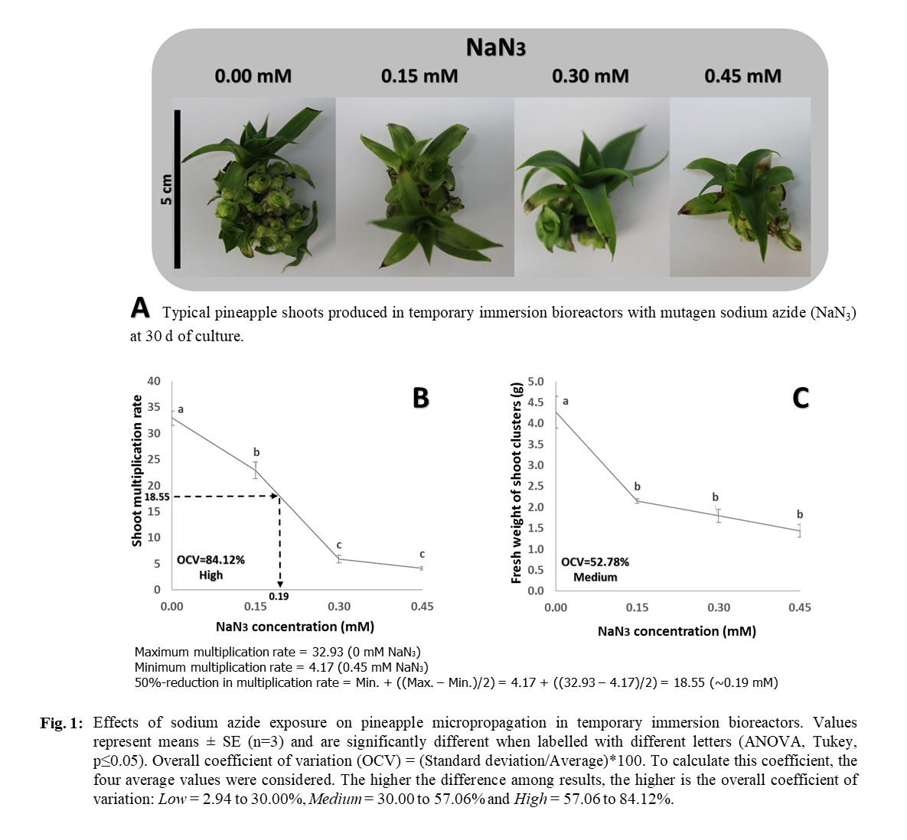
While tissue soluble phenolics (Fig. 2D) increased relative to the control, soluble phenolics levels in the culture medium (Fig. 2F) decreased within increasing NaN₃ concentrations, but OCVs were again Low (18.15 and 28.22%, respectively). Interestingly, NaN₃ had no significant effects on the levels of cell wall-linked phenolics (Fig. 2E), malondialdehyde (Fig. 2G) or other aldehydes (Fig. 2H).
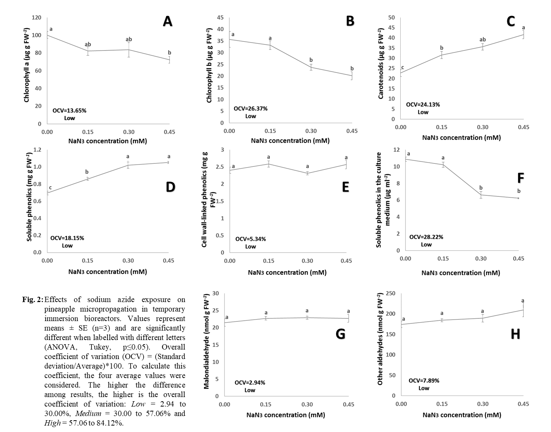
Discussion
In light of a predicted reduction in agricultural productivity in many parts of the world due to climate change, induced mutation technology for crop improvement has become an increasing important area of research over the last few decades (Dubey et al., 2017). In this regard, chemical mutagens are now useful tools in crop improvement and have been used to produce abiotic stress tolerance and disease resistance in various susceptible crops, improving their yield and quality traits (Olawuyi and Okoli, 2017). There are several mutagens available for crop improvement and like NaN_{3,} the mutagen investigated here, each has its own positive or negative effect on plants (Heslot, 1977).
Mutagenesis has been employed to introduce many useful traits, including plant size, fruit ripening and resistance to pathogens in a wide range of fruit crops (reviewed by Lamo et al. (2017)). However, studies on the effects of chemical mutagens on pineapple are scarce (Paull et al., 2017), while no published reports on the effects of NaN₃ on the in vitro growth and biochemistry of pineapple explants were available at the time of this study. In the present study NaN₃ decreased shoot multiplication rate and cluster fresh weight (Figs 1B, 1C). NaN₃ has been reported to have similar inhibitory effects on in vitro explant growth in other species (Dubey et al., 2017; Hussain et al., 2017; Olawuyi and Okoli, 2017; Szarejko et al., 2017). However, at 0.19 mM NaN_{3,} the multiplication rate (1:19) in the TIBs used was lower than the control but still higher to that achieved for pineapple grown in the absence of NaN₃ using conventional culture methods (1:8) (Escalona et al., 1999). Furthermore the propagants generated displayed no morphological abnormalities, when compared to the control (Fig. 1A).
Sodium azide did, however, induce significant changes in a number of biochemical parameters relative to the control. Most plants grown in vitro have a different metabolism than in vivo. In the former, they are provided with a carbon source, growth regulators, high humidity, and less carbon dioxide and light, which promote proliferation but also change the autotrophic metabolism to heterotrophic or mixotrophic (Chandra et al., 2010). Once transferred to the ex vitro environment, micropropagated plantlets must then adapt their metabolism to the new conditions, which can represent a significant stress (Teixeira et al., 2017). The biochemical profile of micropropagated plantlets can therefore influence, either negatively or positively, their survival and performance during acclimatization and subsequent ex vitro growth (Hazarika et al., 2006).
In the present study while in vitro exposure to NaN₃ decreased chlorophyll levels (a and b) in pineapple shoots, it increased carotenoid levels. Carotenoids are important components of the antioxidant system in photosynthetic organisms and their absence can increase the extent of photoinhibition (Cabrera, 2002). Both the decreased chlorophyll and increased carotenoid levels suggest that NaN₃ exposure may reflect a NaN₃-stress-related photosynthetic down-regulation capacity and enhanced photoprotection. Increased carotenoid-based photoprotection is a commonly reported stress response (Pompelli et al., 2010). This may have in turn decreased the potential for photo-oxidation, which can arise as a consequence of stress induced damage to the photosynthetic machinery. This suggestion is supported by the fact that NaN₃ exposure did not result an increase in malondialdehyde and other aldehyde levels (Fig. 2G, 2H) which are common products of cellular damage caused by (photo) oxidative stress (Dumet and Benson, 2000). Under normal growth conditions, basal levels of aldehydes remain low in plant tissues but with exposure to abiotic stress they can accumulate to much higher levels (Sershen et al., 2016). Stress-induced aldehydes can act as generic signal molecules for plants under adverse environmental conditions, inhibiting developmental and metabolic processes (Mostofa et al., 2015). Yadav et al. (2005) for example, showed that the accumulation of aldehydes can inhibit shoot growth.
Phenolic compounds are some of the most common products of secondary metabolism in plants and some are essential for plant survival, given their involvement in defense mechanisms under stress situations (Sharma et al., 2012). The regulation of the biosynthesis of phenolics is generally brought about by biotic and abiotic stimuli (Bettaieb et al., 2011) and generally accumulate in plant tissues during a stress (Joseph et al., 2015). In the present study, though NaN₃ exposure induced a reduction in growth, an unambiguous indication of stress, it did not increase phenolic levels in shoot tissues (Figs 2D, 2E) and or the culture medium (Fig. 2F). This is encouraging, since cell wall-linked or insoluble phenolics, in particular, can make cell walls more rigid and less porous inhibiting nutrient uptake and growth (Kabera et al., 2014). Their accumulation in in vitro cultures is therefore not beneficial for growth (Machakova et al., 2008).
The results suggest that though NaN₃ decreased pineapple shoot multiplication rate within TIBs, propagants displayed no morphologically abnormalities, and when produced using 0.19 mM NaN₃ exhibited enhanced levels photoprotective pigments and no obvious signs of enhanced lipid peroxidation. The mutagen can therefore be used at this concentration to induce pineapple mutagenesis in TIB based studies aimed at producing agriculturally-useful mutants.
Author contribution
DG, LH, JM, JQ, BEZ, S, LY and JCL designed the research; DG, LH and JM conducted the experiments; DG, LH, JM, JQ, BEZ, S, LY and JCL analyzed the data and wrote the paper; and JCL had primary responsibility for the final content. All authors have read and approved the final manuscript.
Acknowledgements
This research was supported by the Bioplant Centre (University of Ciego de Ávila, Cuba), the Escuela Superior Politécnica Agropecuaria de Manabí Manuel Félix López (Ecuador), and the University of Kwazulu-Nathal (South Africa).
Compliance with ethical standards
Conflict of interest Authors do not have any conflict of interests.
Human and animal rights This research did not involve experiments with human or animal participants.
Informed consent: Informed consent was obtained from all individual participants included in the study. Additional informed consent was obtained from all individual participants for whom identifying information is included in this article.
References
Adamu, A.K., Aliyu, M., 2007: Morphogical effects of sodium azide on tomato (Lycopersicon esculentum Mill). Sci. World J. http://dx.doi.org/10.4314/swj.v2i4.51755 2.
Albro, P.W., Corbett, J.T., Schroeder, J.L., 1986: Application of the thiobarbituric acid assay to the measurement of lipid peroxidation products in microsomes. J. Biochem. Biophys. Meth. 13, 185-194.
Alvard, D., Cote, F., Teisson, C., 1993: Comparison of methods of liquid medium culture for banana micropropagation. Plant Cell Tiss Org Cult 32, 55-60.
Bettaieb, I., Bourgou, S., Hamrouni-Sellami, I., Limam, F., Marzouk, B., 2011: Drought effects on polyphenol composition and antioxidant activities in aerial parts of Salvia ofﬁcinalis L. Acta Physiol. Plant. 33, 1103-1111.
Cabrera, H., 2002: Respuestas ecofisiológicas de plantas en ecosistemas de zonas con clima mediterráneo y ambientes de altamontaña. Revista chilena de Historia natural 75, 625-637.
Castillo, A.M., Cistué, L., Vallés, M.P., Sanz, J.M., Romagosa, I., Molina-Cano, J.L., 2001: Efficient production of androgenic doubled-haploid mutants in barley by the application of sodium azide to anther and microspore cultures. Plant Cell Rep. 20, 105–111.
Chandra, S., Bandopadhyay, R., Kumar, V., Chandra, R., 2010: Acclimatization of tissue cultured plantlets: from laboratory to land. Biotech. Lett. 32, 1199-1205.
Chen, C.L., Wang, H.H., Jeng, T.L., Chuang, S.J., Wei, M.L., Jih Min, S., 2011: Genetic diversity in NaN₃-induced common bean mutants and commercial varieties detected by AFLP. Crop Breed. Appl. Biotechnol. 11, 365-369.
Daquinta, M., Benegas, R., 1997: Brief review of tissue culture of pineapple. Pineapple Newsl. 3, 7-9.
Divanli-Türkan, A., Mahmood, K., Khawar, C., Yaşar, C., Ozcan, S., 2006: Effects of mutagenic sodium azide (NaN₃) on in vitro development of four pea (Pisum sativum L.) cultivars. Int. J. Agric. Biol. 8.
Dubey, S., Bist, R., Misra, S., 2017: Sodium azide induced mutagenesis in wheat plant. World J. Pharm. Pharmac. Sci. 6, 294-304.
Dumet, D., Benson, E.E., 2000: The use of physical and biochemical studies to elucidate and reduce cryopreservation induced damage in hydrated/desiccated plant germplasm. In: F. Engelmann, H. Takagi (eds) Cryopreservation of Tropical Plant Germplasm: Current Research Progress and Application. JIRCAS/IPGRI, Tsukuba/Rome.
El Kaaby, E., Abdulkareem, J., Al-Ajeel, S., Abdulhadi, A., Jenan, A., Al-Aubaidy, A., Ammar, K., 2015: Effect of the chemical mutagens sodium azide on plant regeneration of two tomato cultivars under salinity stress condition in vitro. J. Life Sci. 9, 27-31.
Escalona, M., Lorenzo, J.C., González, B., Daquinta, M., Borroto, C., González, J.L., Desjardines, Y., 1999: Pineapple micropropagation in temporary immersion systems. Plant Cell Rep. 18, 743-748.
FAOSTAT, 2016: http://faostat.fao.org/site/567/DesktopDefault.aspx?PageID=567.
Gruszka, D., Szarejko, I., Maluszynski, M., 2012: Sodium azide as a mutagen. In: Q.Y. Shu, B.P. Forster, H. Nakagawa (eds) Plant mutation breeding and biotechnology. CABI, The United Kingdom.
Gurr, S., McPherson, J., Bowles, D., 1992: Lignin and associated phenolic acids in cell walls. In: D.L. Wilkinson (ed) Molecular Plant Pathology. Oxford Press, Oxford.
Hazarika, B.N., da Silva, J.A.T., Talukdar, A., 2006: Effective Acclimatization of in Vitro Cultured Plants: Methods, Physiology and Genetics. Floriculture, Ornamental and Plant Biotechnology 2, 427-438.
He, Y., Wan, G., Jin, Z., Xu, L., Tang, G., Zhou, W., 2011: Mutagenic treatments of cotyledons for in vitro plant regeneration in oilseed rape. Biotechnol.: Gen. Appl. 54.
Heath, R., Packer, J., 1968: Photoperoxidation in isolated chloroplast: I. Kinetics and stoichiometry of fatty acid peroxidation. Arch Biochem Biophys 125, 189-198.
Heslot, H., 1977: Review of main mutagenic compounds. Manual on Mutation Breeding: Technical Reports. IAEA, Vienna.
Hoagland, R.E., 1990: Alternaria cassiae alters phenylpropanoid metabolism in Sicklepod (Casia obstusifolia). J. Phytopathol. 130, 177-187.
Hussain, S., Khan, W.M., Khan, M.S., Akhtar, N., Umar, N., Ali, S., Ahmed, S., Shah, S.S., 2017: Mutagenic effect of sodium azide (NaN₃) on M₂ generation of Brassica napus L. (variety Dunkled) Pure. Appl. Biol. 6, 226-236, http://dx.doi.org/10.19045/bspab.2017.60018.
Ibrahim, R., Hamzah, A., Jam, Z.J., Bahagia, M., Joyo, M., 2009: Gamma Irradiation-Induced Mutation for the Improvement of Josapine Pineapple Against Bacterial Heart Rot Disease and Improved Fruit Quality. International Atomic Energy Agency, Vienna, 276-278.
Jiménez, E., Pérez, N., De Feria, M., Barbón, R., Capote, A., Chávez, M., Quiala, E., Pérez, J.C., 1999: Improved production of potato microtubers using temporary immersion system. Plant Cell Tiss. Org. Cult. 59, 19-23.
Joseph, E.A., Radhakrishnan, V., Mohanan, K., 2015: Variation in accumulation of phenolics in some native rice cultivars of north Kerala, India in response to salt stress. Asian J. Agric. Res 9, 315-324.
Kabera, J.N., Semana, E., Mussa, A.R., He, X., 2014: Plant secondary metabolites: biosynthesis, classification, function and pharmacological properties. J Pharm Pharmacol 2, 377-392.
Lamo, K., Bhat, D.J., Kour, K., Solanki, S.P.S., 2017: Mutation Studies in Fruit Crops: A Review. Int. J. Curr. Microbiol. App. Sci 6, 3620-3633.
Lichtenthaler, H.K., 1987: Chlorophylls and carotenoids: pigments of photosynthetic biomembranes. Meth Enzymol. 148, 350-382.
Loison-Cabot, C., Lacoeuilhe, J.-J., 1989: A genetic hybridization programme for improving pineapple quality. International Symposium on the Culture of Subtropical and Tropical Fruits and Crops.
Lorenzo, J.C., Yabor, L., Medina, N., Quintana, N., Wells, V., 2015: Coefficient of variation can identify the most important effects of experimental treatments. Not. Bot. Horti. Agrobo. Cluj-Nap. DOI:10.15835/nbha4319881. 43, 287-291.
Machakova, I., Zazimalova, E., George, E.F., 2008: Plant growth regulators I: Introduction; auxins, their analogues and inhibitors. In: E.F. George, M. Hall, G.J. De Kerk (eds) Plant Propagation by Tissue Culture. Springer, Dordrecht.
Martín, E.C., Arana, A., González, J.J.R., Encina, C.L., 2015: Piña tropical (Ananas comosus L.): origen, distribución e importancia. Variedades y germoplasma. Agríc. Verg.: Frut., Horticult., Floricult. 34, 249-252.
Mendiondo, G.M., Gibbs, D.J., Szurman-Zubrzycka, M., Korn, A., Marquez, J., Szarejko, I., Maluszynski, M., King, J., Axcell, B., Smart, K., Corbineau, F., Holdsworth, M.J., 2016: Enhanced waterlogging tolerance in barley by manipulation of expression of the N-end rule pathway E3 ligase. Plant Biotechnol. J. 14, 40–50.
Mensah, J.K., Obadoni, B., 2007: Effects of sodium azide on yield parameters of groundnut (Arachis hypogaea L.). African J. Biotech. 6, 668-671.
Mostofa, M.G., Hossain, M.A., Fujita, M., 2015: Trehalose pretreatment induces salt tolerance in rice (Oryza sativa L.) seedlings: oxidative damage and co-induction of antioxidant defense and glyoxalase systems. Protoplasma 252, 461-475.
Murashige, T., Skoog, F., 1962: A revised medium for rapid growth and bioassays with tobacco tissue culture. Physiol. Plant. 5, 473-497.
Olawuyi, O.J., Okoli, S.O., 2017: Genetic variability on tolerance of maize (Zea mays L.) genotypes induced with sodium azide mutagen. Mol. Plant Breed. 8, 27-37.
Paull, R.E., Bartholomew, D.P., Chen, C.C., 2017: Pineapple breeding and production practices. Handbook of Pineapple Technology: Production, Postharvest Science, Processing and Nutrition, 16-38.
Pompelli, M.F., Martins, S.C., Antunes, W.C., Chaves, A.R., DaMatta, F.M., 2010: Photosynthesis and photoprotection in coffee leaves is affected by nitrogen and light availabilities in winter conditions. J. Plant Physiol. 167, 1052-1060.
Porra, R., 2002: The chequered history of the development and use of simultaneous equations for the accurate determination of chlorophylls a and b. Photosynth Res 73, 149-156.
Ragunathan, I., Panneerselvam, N., 2007: Antimutagenic potential of curcumin on chromosomal aberrations in Allium cepa. J. Zhejiang Univ. Sci. 8, 470-475.
Salvi, S., Druka, A., Milner, S.G., Gruszka, D., 2014: Induced genetic variation, TILLING and NGS-based cloning. In: J. Kumlehn, N. Stein (eds) Biotechnological Approaches to Barley Improvement, Biotechnology in Agriculture and Forestry 69. Springer, Berlin.
Sershen, Varghese, B., Naidoo, C., Pammenter, N., 2016: The use of plant stress biomarkers in assessing the effects of desiccation in zygotic embryos from recalcitrant seeds: challenges and considerations. Plant Biol. 18, 433-444.
Sharma, P., Jha, A.B., Dubey, R.S., & Pessarakli, M., 2012: Reactive oxygen species, oxidative damage, and antioxidative defense mechanism in plants under stressful conditions. J. Bot. 2012.
Siddiquia, M., Meghvansia, K., Hasanb, Z., 2007: Cytogenetic changes induced by sodium azide (NaN3) on Trigonella foenum-graecum L. sedes. South Afr. J. Bot. 73, 632-635.
Szarejko, I., Szurman-Zubrzycka, M., Nawrot, M., Marzec, M., Gruszka, D., Kurowska, M., Chmielewska, B., Zbieszczyk, J., Jelonek, J., Maluszynski, M., 2017: Creation of a TILLING population in barley after chemical mutagenesis with sodium azide and MNU. In: J.J.-C.e. al. (ed) Biotechnologies for Plant Mutation Breeding. International Atomic Energy Agency.
Teixeira, J., Hossain, M.M., Sharma, M., Dobránszki, J., Cardoso, J.C., Songjun, Z., 2017: Acclimatization of in vitro-derived Dendrobium. Hort. Plant J. 3, 110-124.
Vainstein, A., 2002: Breeding for ornamentals: classical and molecular approaches. Springer Science & Business Media.
Yabor, L., Valle, B., Rodríguez, R.C., Aragón, C., Papenbrock, J., Tebbe, C.C., Lorenzo, J.C., 2016: The third vegetative generation of a field-grown transgenic pineapple clone shows minor side effects of transformation on plant physiological parameters. Plant Cell Tiss Org Cult. DOI :10.1007/s11240-016-0950-4.
Yadav, S.K., Singla-Pareek, S.L., Ray, M., Reddy, M., Sopory, S., 2005: Methylglyoxal levels in plants under salinity stress are dependent on glyoxalase I and glutathione. Biochem. Biophys. Res. Comm. 337, 61-67.
Ziv, M., 1995: In vitro acclimatization. Automation and environmental control in plant tissue culture. Springer.

